Penetration Testing Assessment

1. Engagement Overview
The penetration testing and assessment were conducted against a defined methodology beginning with reconnaissance to gather information, followed by scanning to identify ports and versions and controlled exploitation to validate the risk. Post-exploitation tests were conducted to assess the opportunities for privilege escalation and the potential business impact should a cyber threat arise against the organisation by allowing malicious access. All testing was conducted within the testing limitations and with permission. Evidence such as commands, screenshots, and outputs was recorded to support each finding. The results help prioritise remediation actions, strengthen defences, reduce attack surface, and improve monitoring.

2. Assets
Asset ID | Asset Name | IP Address | Operating System | Services Running | Open Ports | Description
A1 | Target Web Server | 10.129.3.70 | Windows Server 2003 R2 | HTTP (Microsoft IIS 6.0) | 80/tcp | Vulnerable web server with WebDAV enabled and exposed methods
A2 | Attacker Machine | 10.10.14.23 | Kali Linux | Netcat, Metasploit | 4444/tcp | Used for exploitation, reverse shell handling, and post-exploitation
A3 | Local Interface | 192.168.56.103 | Linux (Kali Host Interface) | Network Interface | N/A | Local network interface used for connectivity and testing
A4 | VPN Tunnel Interface | 10.10.14.23 | Kali (tun0 Interface) | VPN Tunnel | N/A | Used to communicate with Server

3. Reconnaissance & Enumeration
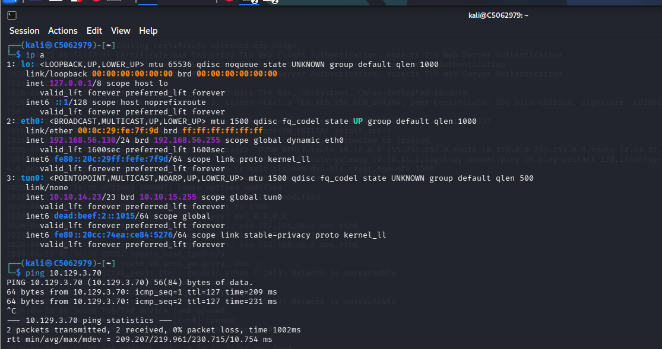
Figure 2– Network Interface Configuration & Connectivity Verification
The ip a command lists the active network interfaces: loopback (lo), Ethernet (eth0), both with IPv4 192.168.56.103 and IPv6, and tunnel (tun0) with VPN address 10.10.14.23. The ping after 10.129.3.70 to bidirectional ICMP deliverability with an average RTT of ~209ms and 0.00 packet loss.
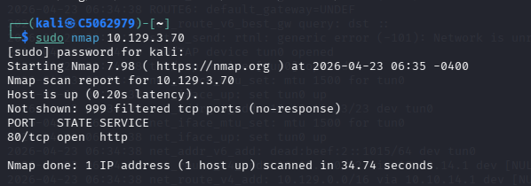
Figure 3: Basic Nmap TCP Port Scan
Nmap 7.98 scans 10.129.3.70 on the default SYN scan, and finds that 999 TCP ports are reflected as non-responding with a filter. It is open only port 80/tcp, which is running HTTP. Host latency is 0.20s, which is correct as it is an Windows IIS web server.
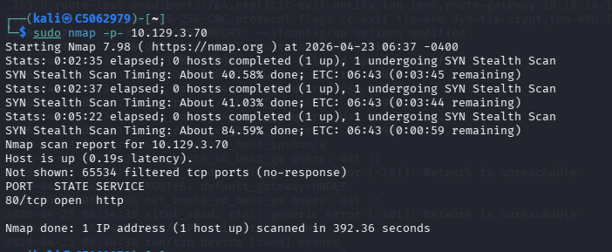
Figure 4: Full-Port Nmap Scan
A 65535-port SYN stealth scan, used exhaustively, against 10.129.3.70 takes 392 seconds. Findings indicate that only port 80/tcp is open. There are about 65534 filtered ports with the aggressive firewall policies at work that only allow HTTP traffic to be ingress.
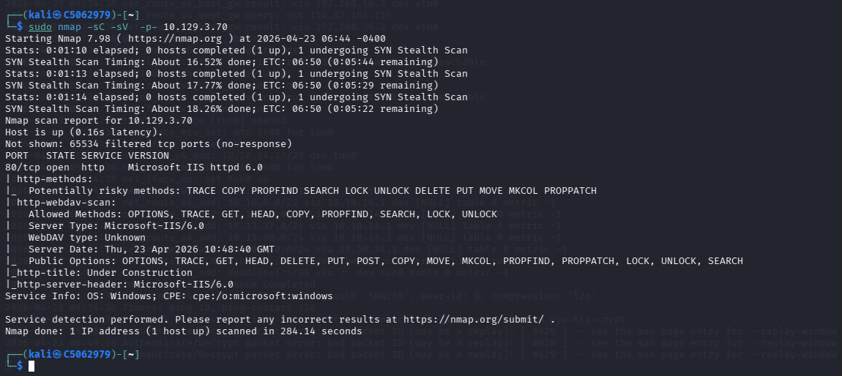
Figure 5: Nmap Service/Version Detection with Script Scanning
With -sC -sV -p-, Nmap recognises port 80 as Microsoft IIS 6.0, which is operated on a Windows Server 2003 R2. Listed are WebDAV methods such as PROPFIND, PUT, MOVE and DELETE. The http-webdav-scan script shows that WebDAV is active and has all the methods exposed.
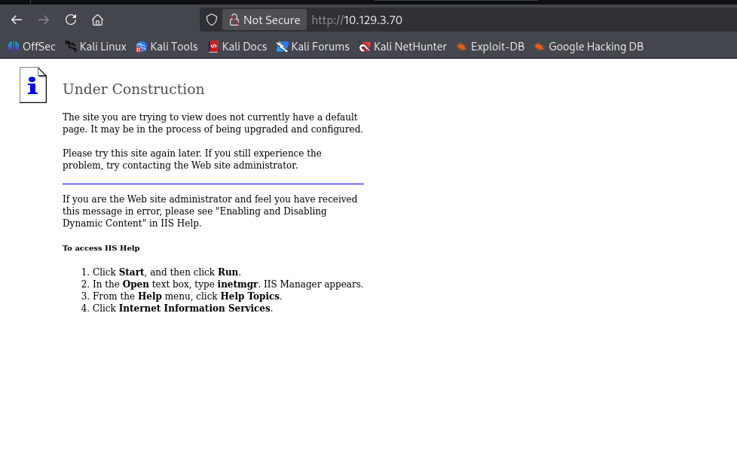
Figure 6: IIS Web Server Default Page Enumeration
Opening up the browser to the URL http://10.129.3.70, one can see the default Microsoft IIS Under Construction page, thus proving the absence of an application deployed. This server has not been configured to have a default document, prone to attack vectors of WebDAV.
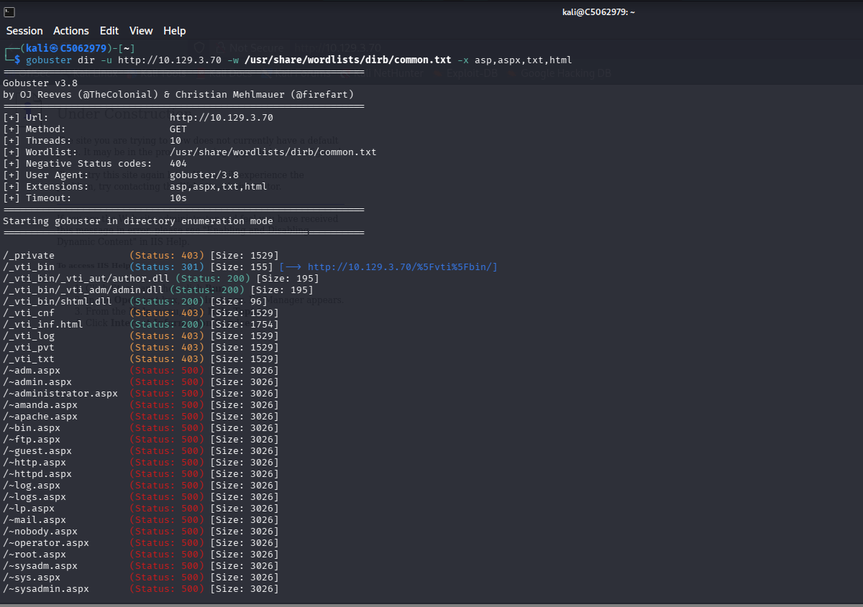Figure 7: Gobuster Directory/File Enumeration
Gobuster v3.0 is run with 10.129.3.70 with common.txt wordlist including extensions asp, aspx, txt, html, and conducts directory brute-forcing. Findings reveal /private (403) and /_vti_bin (200), /vti_aut/author.dll (200) and /vti_adm/admin.dll (200) which prove that FrontPage Server Extensions are enabled.
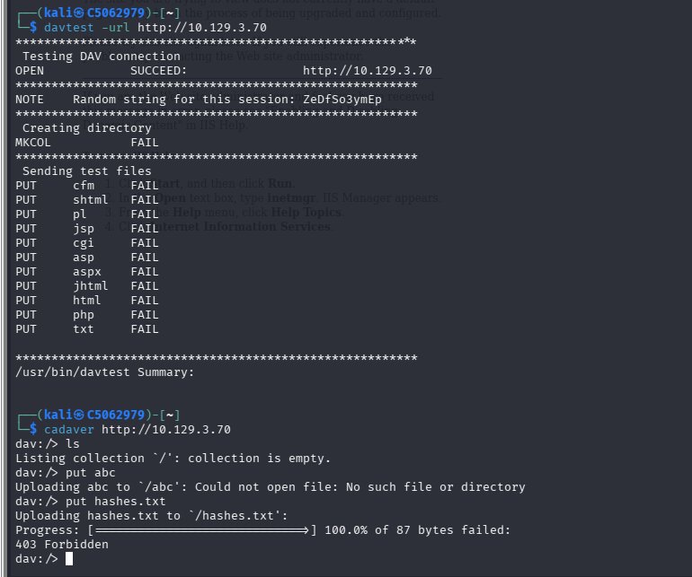
Figure 8: DAVTest & Cadaver WebDAV Write Permission Testing
Davtest tests WebDAV write operations, put of file (cfm, asp, aspx, html, php, txt, and all directory operations that require MKCOL) all show FAIL, which means that it can not write anything. Cadaver checks hash.txt (hashes.txt upload) 403 Designedates forbidden uploads.
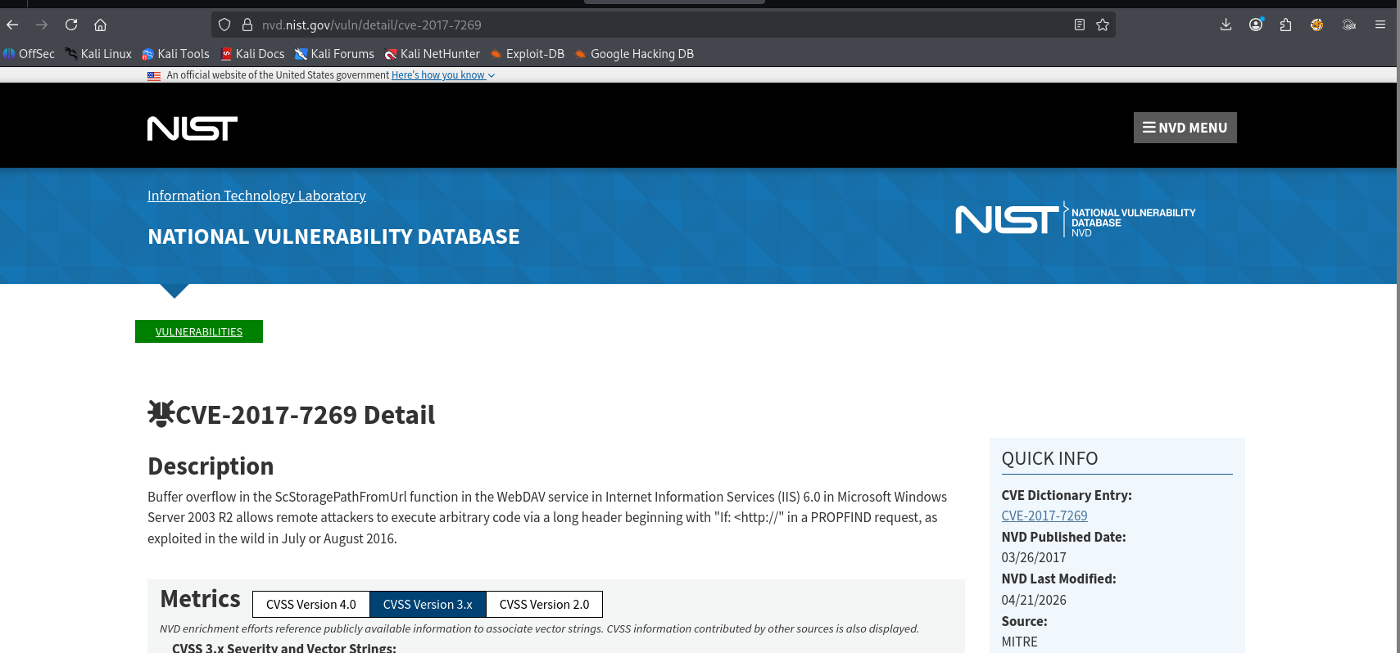
Figure 9: CVE-2017-7269 Vulnerability Research on NVD
NIST National Vulnerability Database entry of CVE-2017-7269 is analysed. The vulnerability talks about a buffer overflow in the ScStoragePathFromUrl function of the WebDAV service of IIS 6.0 that allows arbitrary code execution by remote users through a composed long header in a PROPFIND request, exploited in the wild in 2016.

4. Exploitation & Initial Access
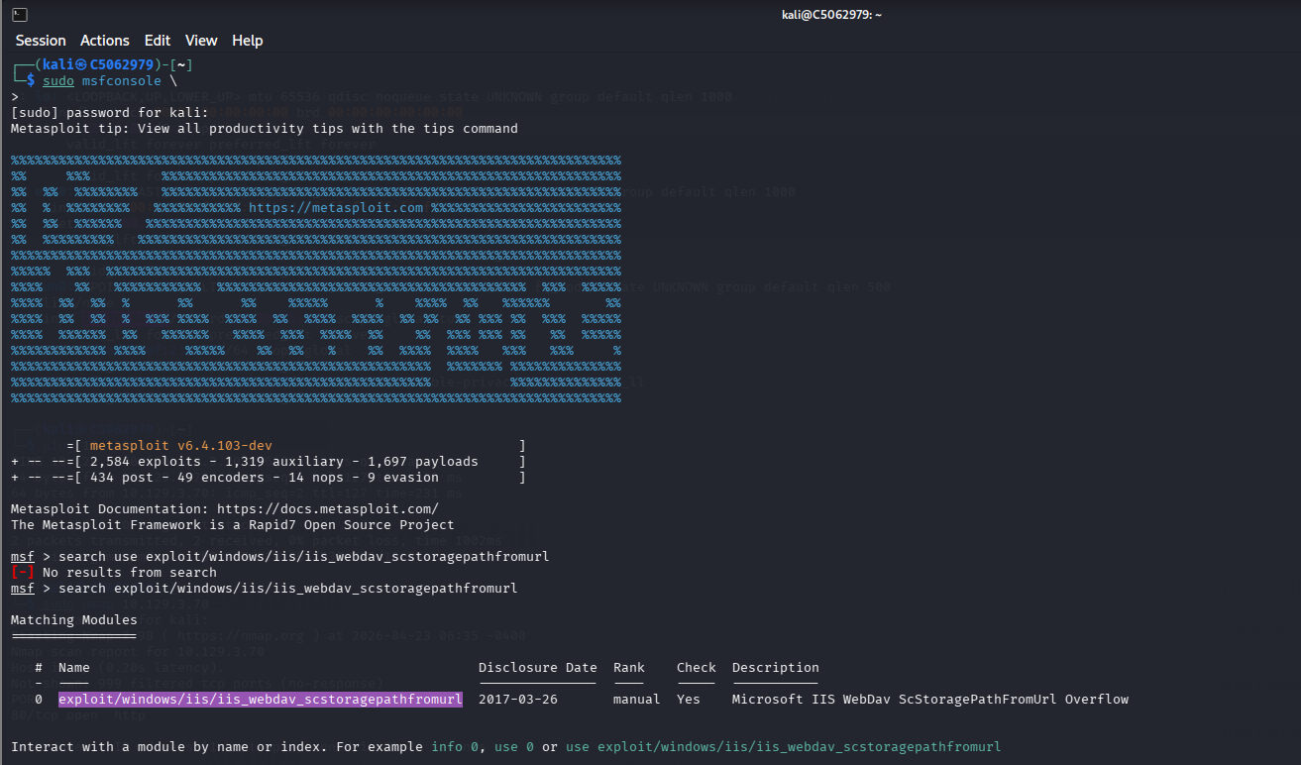Figure 16: Metasploit Framework Search for IIS WebDAV Exploit Module
Metasploit exploit/windows/iis/iis_webdav_scstoragepathfromurl. The result of the search shows a single matching disclosed module on 2017-03-26, with its target being Microsoft IIS WebDAV ScStoragePathFromUrl buffer overflow (CVE-2017-7269) on the IIS 6.0 target.
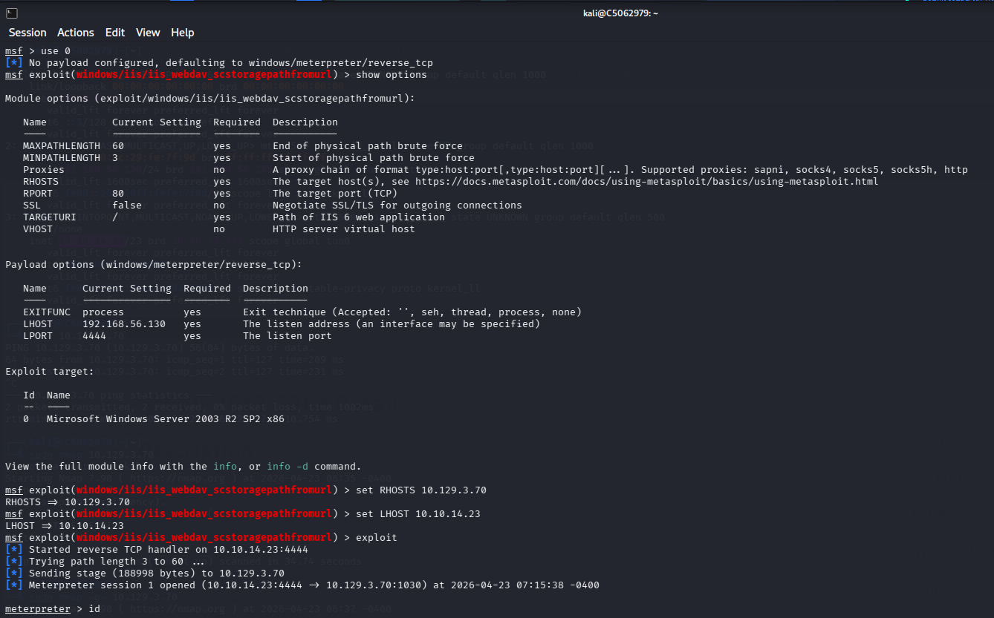Figure 17: Metasploit Module Configuration & Meterpreter Session Establishment
The default settings in the iis_webdav_scstoragepathfromurl exploit module are configured with a Windows/meterpreter/reverse_tcp payload. The execution starts a reverse TCP handler on port 4444 and is able to brutally force path length, and has delivered a 188998-byte stage and opens a Meterpreter session 1 on the target.
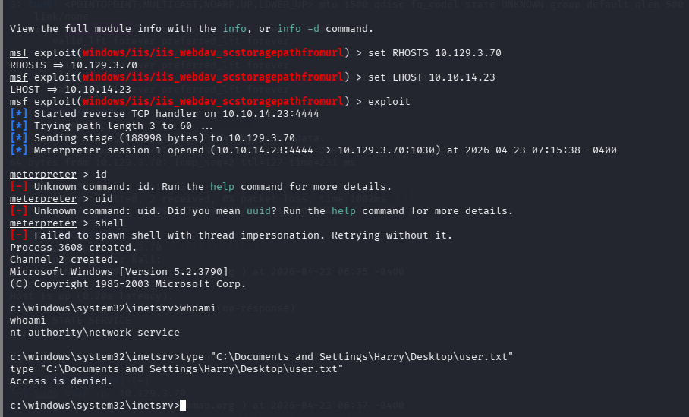
Figure 18: Meterpreter Access Using WebDAV
Post-session identid and UIDs give the unknown error, and invocation of shell (thread impersonation) gives the default fallback (Channel 2). It acquires a shell of Windows Server 2003, which is running as the NT AUTHORITY as NETWORK SERVICE.

5. Privilege Escalation & Post-Exploitation
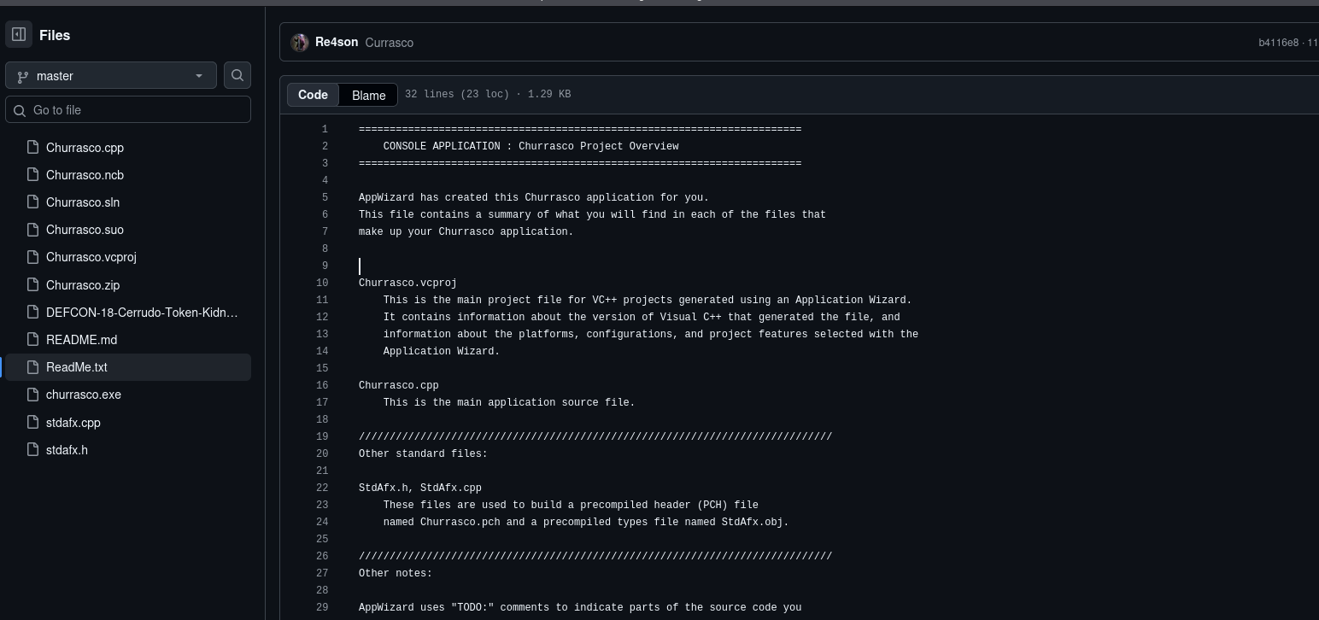Figure 24: SYSTEM Shell via Churrasco & Flag Retrieval
A GitHub repository of the Churrasco privilege escalation tool is browsed, showing the overview of an AppWizard-generated Visual C++ console application. The project includes Churrasco.cpp (main source), Churrasco. vcproj (build configuration), stdafx files (precompiled header), and a token-kidnapping reference of defcon-18. This is a Windows token exploit that targets NETWORK SERVICE to SYSTEM elevation.
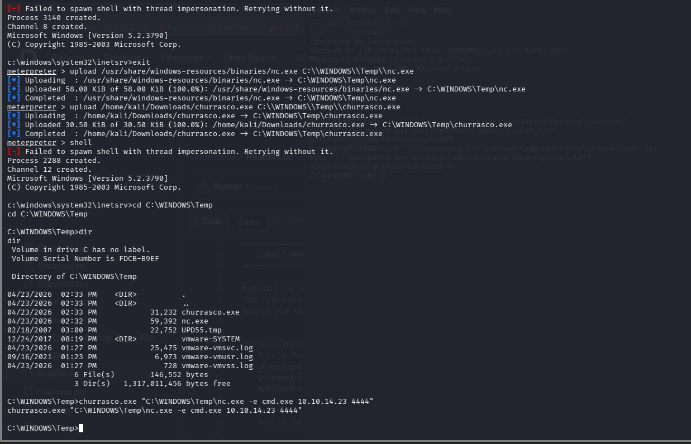
Figure 25: Meterpreter Shell Access
Shows a Meterpreter session where file uploads and shell execution are performed on the target server. Tools like nc.exe and churrasco.exe are uploaded to the Temp directory to gain elevated access. Despite impersonation failure, a shell is obtained, directories are listed, and a reverse shell is initiated.
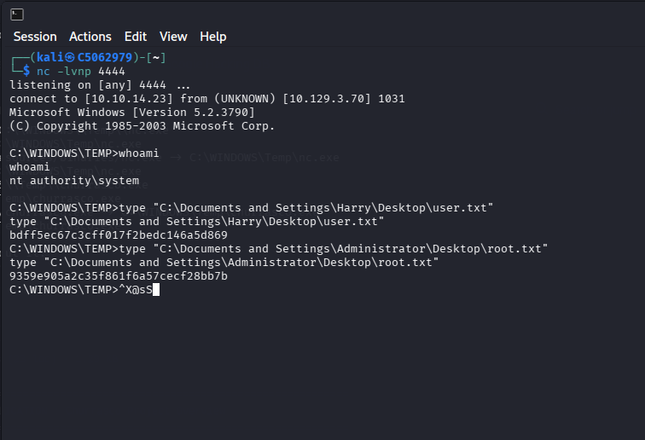
Figure 26: Remote Shell Access
The remote shell successfully connected with the target machine. The “whoami” command reveals SYSTEM-level privileges, indicating full administrative control over the compromised target system.

6. Risk Matrix

Risk ID | Vulnerability | Likelihood | Impact | Risk Level | Description
R1 | Outdated IIS 6.0 Server | High | High | Critical | Legacy system (Windows Server 2003) is unsupported and highly vulnerable to exploits
R2 | WebDAV Enabled with Dangerous Methods | High | High | Critical | Methods like PUT, MOVE, PROPFIND allow attack surface for remote exploitation
R3 | CVE-2017-7269 Buffer Overflow | High | High | Critical | Allows remote code execution via crafted HTTP request
R4 | Open Port 80 (HTTP) | High | Medium | High | Public exposure increases attack surface
R5 | Default IIS Configuration | Medium | Medium | Medium | Misconfiguration leads to information disclosure and weak security posture
R6 | FrontPage Extensions Enabled | Medium | High | High | Known insecure and deprecated components
R7 | Weak Access Control (403 bypass areas) | Medium | Medium | Medium | Sensitive directories exposed during enumeration
R8 | Reverse Shell Access | High | High | Critical | Attacker gains remote command execution
R9 | Privilege Escalation (Churrasco) | High | High | Critical | Elevation from NETWORK SERVICE to SYSTEM
R10 | Lack of Patch Management | High | High | Critical | System not updated, allowing exploitation of known CVEs

7. Remediation & Defensive Measures
Issue ID | Vulnerability | Remediation Action | Priority | Defensive Measure
RM1 | Outdated IIS 6.0 Server | Upgrade to a supported OS (Windows Server 2016/2019+) and latest IIS version | Critical | Regular patch management and system updates
RM2 | WebDAV Enabled | Disable WebDAV if not required | Critical | Restrict HTTP methods (disable PUT, DELETE, MOVE)
RM3 | CVE-2017-7269 Vulnerability | Apply security patches or migrate to secure platform | Critical | Use IDS/IPS to detect exploit attempts
RM4 | Open Port 80 (Unsecured HTTP) | Implement HTTPS (SSL/TLS) and restrict unnecessary exposure | High | Configure firewall to limit access
RM5 | Default IIS Configuration | Remove default pages and configure secure headers | Medium | Harden web server configurations
RM6 | FrontPage Extensions Enabled | Disable/remove FrontPage Server Extensions | High | Regularly audit installed components
RM7 | Directory Enumeration Exposure | Restrict directory listing and enforce proper access controls | Medium | Use WAF to block enumeration attempts
RM8 | Reverse Shell Access | Block outbound connections from server | Critical | Monitor network traffic and use EDR tools
RM9 | Privilege Escalation (Churrasco) | Apply least privilege principle and patch escalation vulnerabilities | Critical | Use endpoint protection and privilege monitoring
RM10 | Lack of Monitoring | Implement centralized logging (SIEM like Splunk/ELK) | High | Continuous monitoring and alerting
RM11 | Weak Authentication/Access Controls | Enforce strong authentication and access policies | High | Use MFA and role-based access control

8. Remarks
The system requires immediate remediation due to multiple critical vulnerabilities. Key actions include upgrading outdated systems, disabling unnecessary services like WebDAV, applying patches, and implementing strong monitoring and access controls. These measures will significantly reduce the risk of unauthorised access and system compromise.

